Applicant(s):  1. Gujarat Council on Science and Technology (GUJCOST),  2. IIT Bhubaneswar | Total No. of Sheets: 7  Sheet No.: 1 of 7

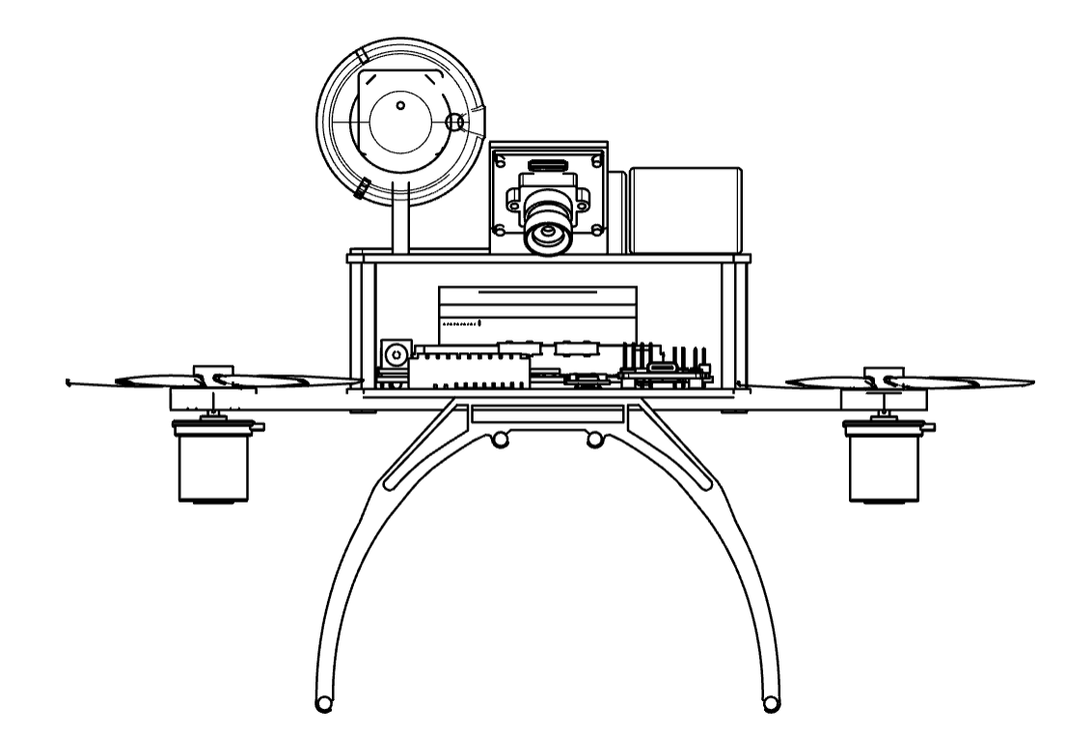

FIG. 1


Dr. Narottam Sahoo  Advisor and Member Secretary  Gujarat Council on Science and Technology  Dept. of Science and Technology, GoG. | Signature:  Prof. Shantanu Pal  Dean, Under Graduate Program  IIT, Bhubaneswar

Applicant(s):  1. Gujarat Council on Science and Technology (GUJCOST),  2. IIT Bhubaneswar | Total No. of Sheets: 7  Sheet No.: 2 of 7
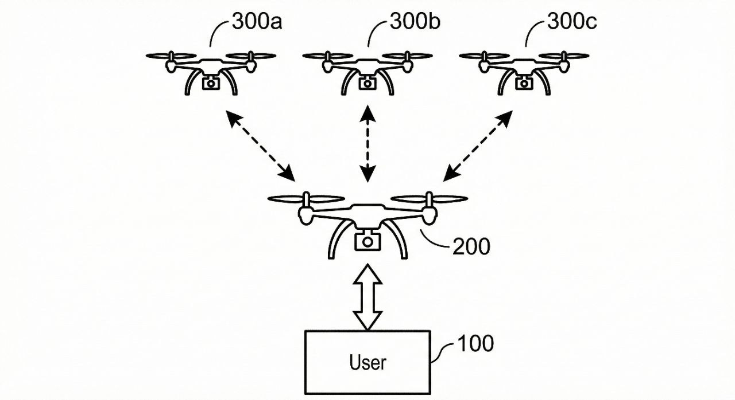

FIG. 2



Dr. Narottam Sahoo  Advisor and Member Secretary  Gujarat Council on Science and Technology  Dept. of Science and Technology, GoG. | Signature:  Prof. Shantanu Pal  Dean, Under Graduate Program  IIT, Bhubaneswar

Applicant(s):  1. Gujarat Council on Science and Technology (GUJCOST),  2. IIT Bhubaneswar | Total No. of Sheets: 7  Sheet No.: 3 of 7

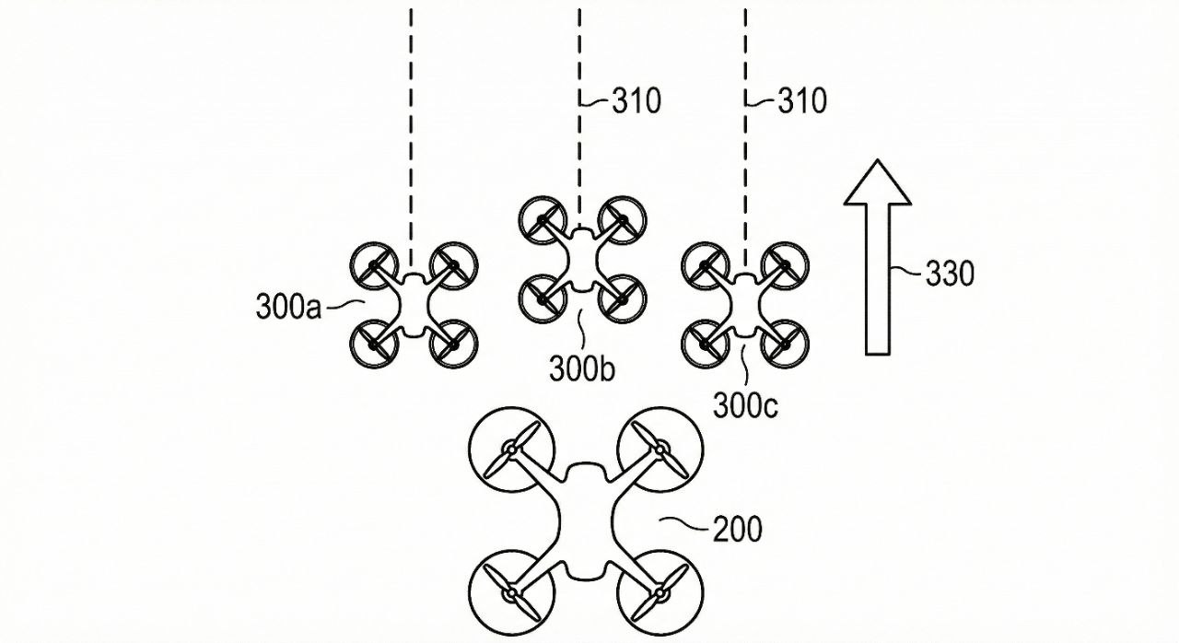

FIG. 3



Dr. Narottam Sahoo  Advisor and Member Secretary  Gujarat Council on Science and Technology  Dept. of Science and Technology, GoG. | Signature:  Prof. Shantanu Pal  Dean, Under Graduate Program  IIT, Bhubaneswar

Applicant(s):  1. Gujarat Council on Science and Technology (GUJCOST),  2. IIT Bhubaneswar | Total No. of Sheets: 7  Sheet No.: 4 of 7

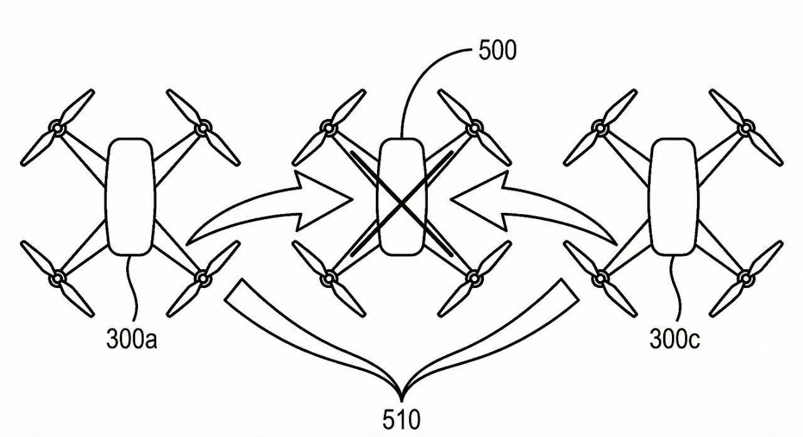

FIG. 4



Dr. Narottam Sahoo  Advisor and Member Secretary  Gujarat Council on Science and Technology  Dept. of Science and Technology, GoG. | Signature:  Prof. Shantanu Pal  Dean, Under Graduate Program  IIT, Bhubaneswar

Applicant(s):  1. Gujarat Council on Science and Technology (GUJCOST),  2. IIT Bhubaneswar | Total No. of Sheets: 7  Sheet No.: 5 of 7

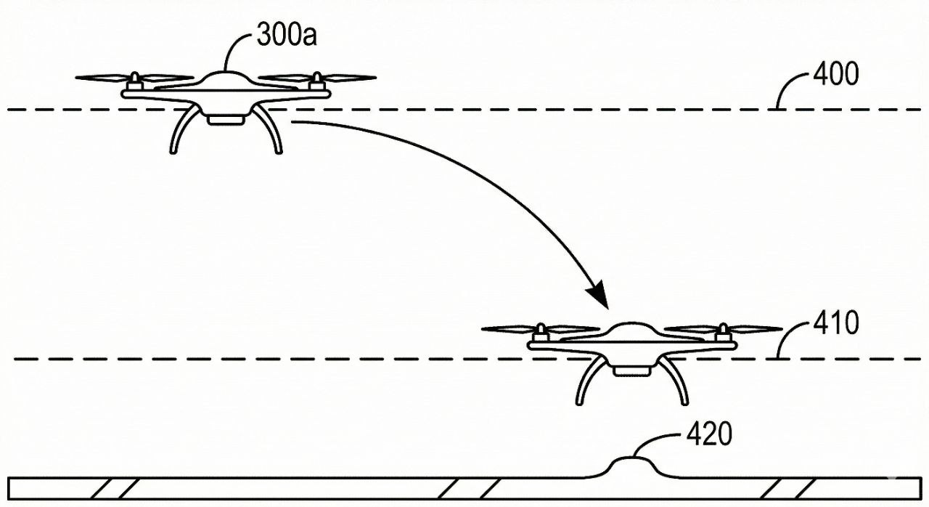

FIG. 5



Dr. Narottam Sahoo  Advisor and Member Secretary  Gujarat Council on Science and Technology  Dept. of Science and Technology, GoG. | Signature:  Prof. Shantanu Pal  Dean, Under Graduate Program  IIT, Bhubaneswar

Applicant(s):  1. Gujarat Council on Science and Technology (GUJCOST),  2. IIT Bhubaneswar | Total No. of Sheets: 7  Sheet No.: 6 of 7

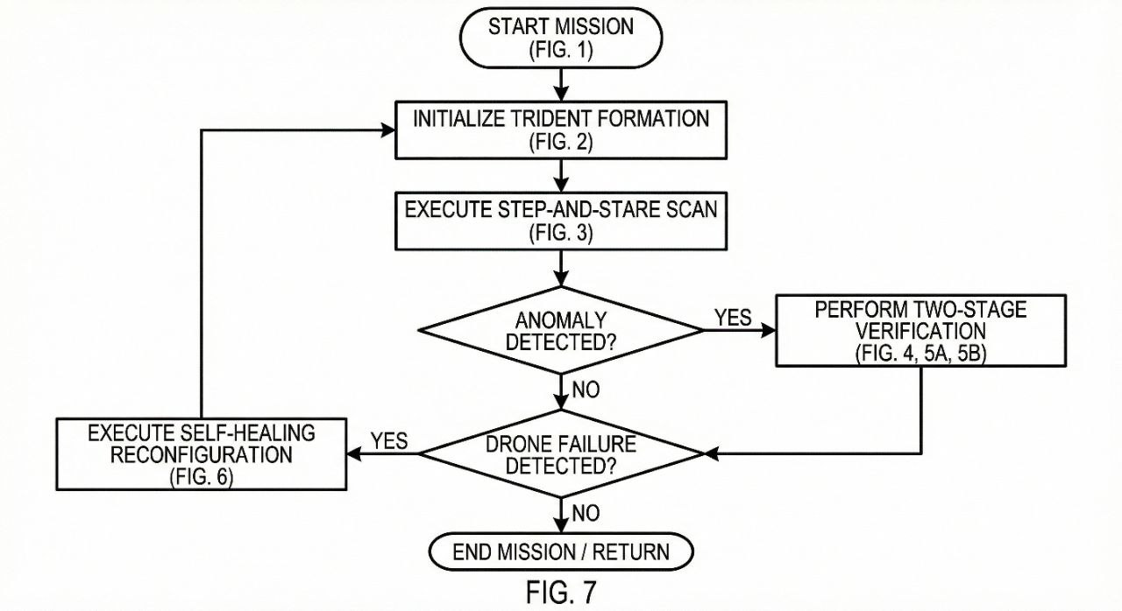

FIG. 6



Dr. Narottam Sahoo  Advisor and Member Secretary  Gujarat Council on Science and Technology  Dept. of Science and Technology, GoG. | Signature:  Prof. Shantanu Pal  Dean, Under Graduate Program  IIT, Bhubaneswar

Applicant(s):  1. Gujarat Council on Science and Technology (GUJCOST),  2. IIT Bhubaneswar | Total No. of Sheets: 7  Sheet No.: 7 of 7

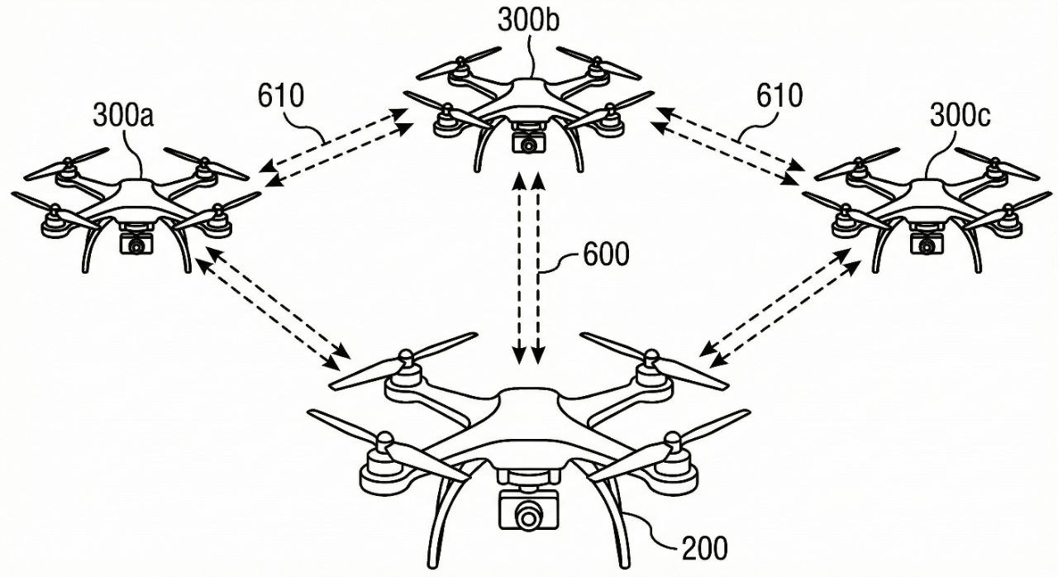

FIG. 7



Dr. Narottam Sahoo  Advisor and Member Secretary  Gujarat Council on Science and Technology  Dept. of Science and Technology, GoG. | Signature:  Prof. Shantanu Pal  Dean, Under Graduate Program  IIT, Bhubaneswar

